Giovanna Di Toro, Annalisa Feliziani,

Leonardo Proietti Cerquoni

**A Journey towards Change: *analysis of the impact of green solutions adopted from firms to foster customer experience***

*Practical phenomenon, managerial relevance and managerial problem.*

Nowadays, a new period of sustainability is emerging, expanding in various areas of the world.

Consumers, especially Millennials, are increasingly tending to want eco-friendly brands and recent reports have stressed that some eco-friendly products have shown double growth compared to traditional ones.

Therefore, this has led consumers to be more aware by purchasing eco-friendly products. The change is happening so fast because sustainability is becoming a vital issue in many parts of the world.

Indeed, the World Health Organization estimates that 12.6 million people die each year from environmental health risks.

Given these problems, consumers across the hemisphere are changing their shopping habits while continuing to juggle convenience, price and awareness.

Corporate responsibility and sustainability strategies may differ from around the world, but consumers are using their purchasing power to make the change they want to see.

Hence, sustainability has become a compelling opportunity for companies to have a greater engagement with consumers who care about the issue.

The histogram below shows the percentage of people who said that it is “extremely” or “very” important that companies implement programs to improve the environment:

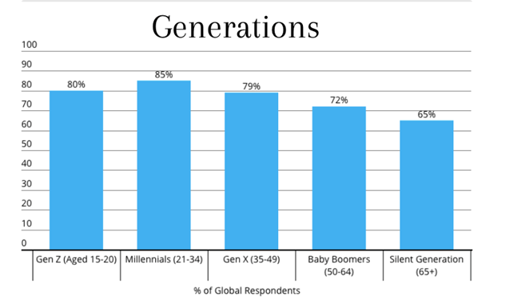

In light of all these considerations, we articulated the following *practical phenomenon:*

**Practical phenomenon**

**There is a general consensus on the established relevance of environmental issues among consumers, namely pollution and climate change. This has shifted attention of consumers towards sustainable, green alternatives.**

This strong increase in environmental awareness led to the formation of new patterns of consumer expectations which has forced brands to respond.

As a consequence, both emerging businesses and well-established ones have been required to adopt solutions towards implementing corporate social responsibility actions.

Therefore, we identified the following as a *managerial relevance*:

**Managerial relevance**

**The result is that firms have been addressing this "green pressure", with the aim to provide goods and services which satisfy consumers' increasing needs for eco-friendly solutions.**

Due to the critical conditions of the world environment, movements of environmental-friendly businesses have become much more prominent.

On the other hand, the concerns regarding the adoption of sustainable solutions may not be necessarily followed by an intention to take action.

Building on these ideas, the final *managerial problem* we are going to investigate in this research is the following:

**Managerial problem**

**However, it is still unclear what is the impact of promoting/selling green products and services on customer engagement and intention to buy.**

Brands need to find the balance between sustainability and convenience as consumers still rank efficacy, value and aesthetics as desired characteristics. Moreover, sustainable products often come with a premium price, and not all consumers are willing to pay more.

Our research deals with consumers’ attitudes and purchase intentions of eco-friendly products and services.

The starting point is that there is no one size-fits-all solution. Diversities can be detected among different markets and consumer types.

Therefore, we conducted our research by constructing queries using the KPI6 platform both from the consumers’ perspective and from the brands’ perspective. Here’s what we have found.

We want, therefore, to have an overall insight of consumer opinions about green products and services. Further research focusing mainly on demographical, geographical and attitudinal fields, will then be possible. Data coming from user-generated content will be helpful to perform this task.

*Choice of brands*

From a business perspective, we are interested in the consumers’ response to brands’ sustainable initiatives and solutions. Social media are nowadays an extraordinary source of useful data. Throughout this study Twitter comes into play allowing us to understand the level of engagement companies are able to get.

In our choice of brands, we made an extensive research which aimed at identifying, on the one hand, well-established businesses which, in order to adapt to changes in customers expectations, adopted green solutions as a response to customers ecological needs: Ikea is a very suitable example of how a well-known and acclaimed firm managed to achieve this by means of many green initiatives; on the other hand, brands which were born with the precise purpose of serving such needs. For instance, Lush whose cosmetic production has always been based on a strong sustainable ethics.

Moreover, we selected brands which were born or which operate in America (USA), Asia and Europe, with the aim to conduct research world-wide.

Our approach is based on developing two separate queries:

* First, a query to analyze the perspective of consumers; to that aim, we collect user-generated data from Twitter whose topics are related to green solutions.
* Then, another query with a business-based perspective: we gather data coming from the social media accounts of the brands we selected, which are either related to green initiatives or are green brands per se. We do this in order to analyze which are the different levels of engagement stemming from different content related to the promotion of green solutions.

The procedure we intend to follow is inductive-based. Therefore, before stating any hypotheses, we collected all the relevant data aimed at helping us develop such hypotheses using the KPI6 Platform.

*Queries*:

* TWITTER (Consumers Perspective)

( @patagonia OR @lushcosmetics OR @Wipro OR Wipro OR @IKEAUSA OR Ikea OR @Nike OR "nike" OR @TOMFORD OR "Tom Ford" OR @Starbucks OR @Google OR google) AND ( sustainability OR sustainable OR reusable OR recycling OR "green lifestyle" OR ( "eco-friendly" OR ecofriendly OR "eco friendly") OR ecology OR nature OR environment OR eco OR ecologia OR "ecological fashion" OR ecological OR "no plastic" OR plasticless OR ( plasticfree OR "plastic-free" ) OR "ecological design" OR "zero waste" OR "save the planet" OR ("Save the earth" OR savetheearth) OR ( "climate change" OR climatechange ) OR wildlife OR biodiversity OR recycle OR recycled OR renewable OR "go green" OR "green energy" OR pollution OR polluted OR pollute OR bio OR "global warming" OR ecoresponsible OR climate OR "ecology today" OR ecosystem OR "future of earth" OR #green OR "clean energy" OR "renewable energy" OR "Ocean Plastic" OR (nowastes OR "no wastes") OR #eco OR ("save the world" OR savetheworld) OR "zero emissions" )

* TWITTER (Business Perspective)

( from:patagonia OR from:lushcosmetics OR from:Wipro OR from:IKEAUSA OR from:Nike OR from:TOMFORD OR from:Starbucks OR from:Google) AND ( sustainability OR sustainable OR reusable OR recycling OR "green lifestyle" OR ( "eco-friendly" OR ecofriendly OR "eco friendly") OR ecology OR nature OR environment OR eco OR ecologia OR "ecological fashion" OR ecological OR "no plastic" OR plasticless OR ( plasticfree OR "plastic-free" ) OR "ecological design" OR "zero waste" OR "save the planet" OR ("Save the earth" OR savetheearth) OR ( "climate change" OR climatechange ) OR wildlife OR biodiversity OR recycle OR recycled OR renewable OR "go green" OR "green energy" OR pollution OR polluted OR pollute OR bio OR "global warming" OR ecoresponsible OR climate OR "ecology today" OR ecosystem OR "future of earth" OR #green OR "clean energy" OR "renewable energy" OR "Ocean Plastic" OR (nowastes OR "no wastes") OR #eco OR ("save the world" OR savetheworld) OR ( "zero emissions" OR zeroemissions ))

*Business Perspective*

We started from the business perspective.

We were mainly interested in analyzing the different levels of engagement stemming from different approaches to green solutions. With the data we got from the brands’ twitter accounts it is interesting to notice that the top 3 brands in terms of engagement compared to the others are those who are louder on their green initiatives. Indeed Tom Ford has recently launched a watch entirely made from Ocean plastic, Patagonia is a sustainable fashion brand, very active in environmental related campaigns on social media and Ikea is quite constant in promoting its sustainable solutions.

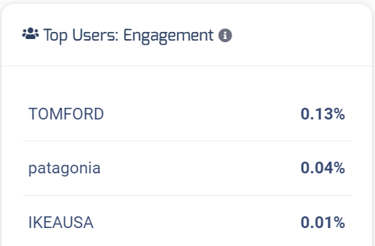

*Consumers Perspective*

For what concerns the User point of view, our study focuses first of all on their intention to buy; a close approximation through the sentiment analysis is what we actually got. We therefore analyze two cases.

*The Tom Ford Case*

The Tom Ford case is relevant because of the launch of its Ocean Plastic made watch on November 19.

The graph below makes evidence of the effects in terms of number of posts. Starting from November 18 there is a peak in the number of posts. The green line represents the tweets posted directly by the brand, and it is interesting to notice how Tom Ford was active on Twitter in the days immediately before and after the launch of the watch. The blue line reflects user-generated posts which starting from the day of the launch reached a peak.

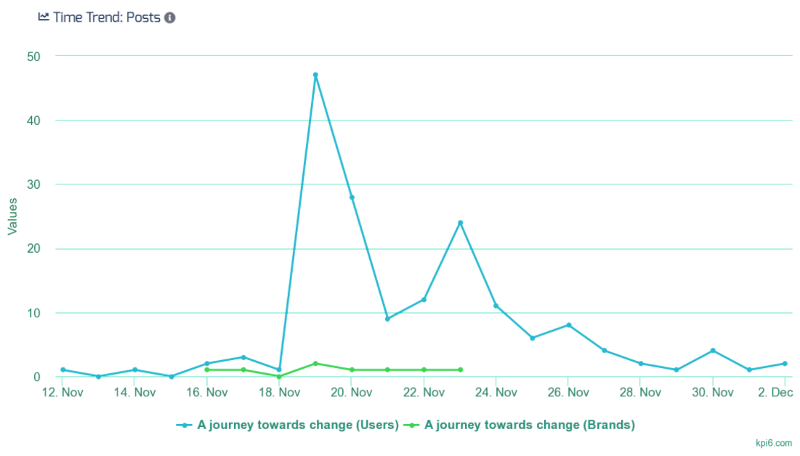

Having assessed that the launch of this watch provoked a significative discussion, our intention is now to come up with a good approximation of consumers intention to buy. To this aim, we proceeded in the following way.

We filtered the Tom Ford related tweets between those posted before the launch date (up to November 18) and those posted after. Then we looked for the consumer attitude through the sentiment analysis.

Before the launch the positivity reaches one hundred.

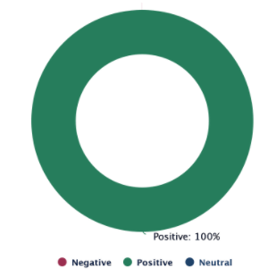

After the launch positivity still gets the most of the posts, but now there is a percentage of negative tone which makes us think that the overall consumers’ positive attitude now is slightly weaker. This, of course, does not represent evidence that the new consumers will buy green products. On the contrary, we can affirm that there is a part of customers which is not interested in this watch and therefore in buying it. In this case one of the reasons is the price of the watch which is not accessible for many.

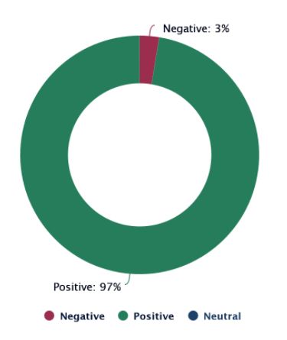

*The Starbucks Case*

The second case we studied concerns Starbucks, which periodically sells reusable cups, for example in this last period they are holidays themed, and also offers discounts for those using reusable cups. The approach here is therefore different: we decided to directly detect the consumer attitude towards these periodical initiatives with the data we had at our disposal.

We found that the discussion involving Starbucks and the reusable cups is quite controversial. The most of the users are positively impacted by such initiatives, but a consistent part manifests concerns which are mainly related to the lack of constancy of this brand.

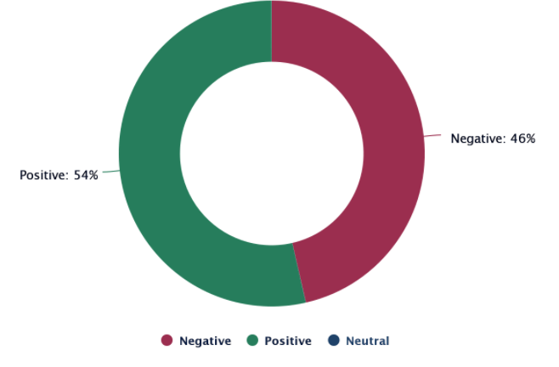

This is found also in the graph above, where the two leading emotions are indeed Admiration and Disapproval. Also in this case, therefore, it is not possible to conclude that all the consumers are willing to buy green.

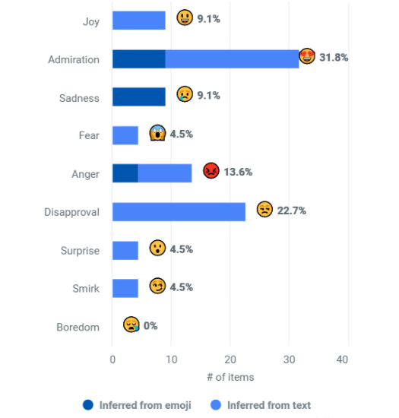

Finally, the second feature we were interested in is the actual level of customer engagement stemming from environmentally related topics. From the query covering user-generated content we were able to detect that for what concerns the overall conversation, the level of engagement is of 1.01%, which is a very consistent value AND this is confirmed by the level of engagement coming from people directly which we observed by filtering out our data.

*Insights*

1. *Happiness is in the Air*

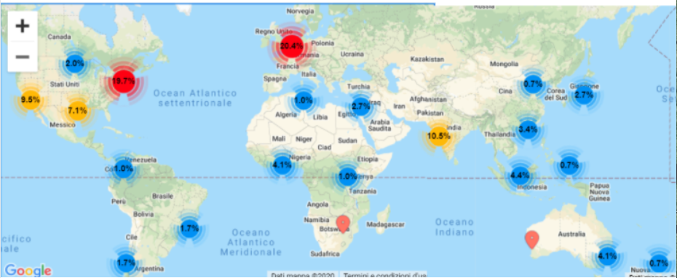

The first insight is that conversations about the topics of eco-sustainability are widespread, as the world-map above shows.

We used the Google Maps extension on the kpi6 platform to dive into the different percentages, which as we can see have different colors: red, orange and blue. In this way, we were able to see that the highest percentages, which are those in red and orange, are in correspondence of the most polluted cities: for example London and Manchester in Europe, New York and Los Angeles in the USA, India and Singapore in Asia.

From this, we were able to conclude that the need for ecological solutions is stronger in places where the problem of pollution is more present: we can argue that “happiness in the air!”

1. *Any publicity is good publicity!*

The second insight is that overall sentiment in green conversations is prevalently positive. This is a good indicator of the fact that consumers care about brands focusing on environmental issues and providing green solutions. However, the percentage of negative sentiment is not so small: one of the main factors is the premium price that brands ask for green products, as we have seen with the Tom Ford example. Another reason is linked to the fact that many firms still put too little effort in the environmental cause, and this is a reason of disapproval from the side of consumers, who claim that firms could do much more given their position.

1. *To buy or not to buy?*

From this, we derived the last conclusion: promoting or selling green products does not necessarily have a positive impact on customers' intention to buy, and in particular it depends on how much and how often brands engage in green initiatives, and also on the price.

This also provides an answer to our initial managerial question.

*Conclusion and Managerial Implications*

First of all, we have clear evidence that people engage with environmentally related topics.

As a consequence, brands should understand this and engage in online conversations facing environmental topics, also giving a continuity to their efforts in terms of time and space.

The more widespread the word, the more the name of these brands will get spread, with a positive impact on their image because they are contributing to a brighter future; in this way, the brand will get more positive publicity worldwide, thanks to WOM.

Finally, firms should be aware that sales are not always the consequence of this engagement. In this sense, neuromarketing can be a powerful tool. In particular, brands should focus on one of the 6 principles of persuasions by Robert Cialdini, the principle of consistency: in short, this affirms that people like to be consistent with the things they have previously said or done.

What does it mean in practice? Brands should engage in small commitments with their users on social media: announcements of new green products followed by surveys on people’s expectations or hopes towards that product, for example.

In general, brands need to interact with users in such a way that in the future they will be committed to their causes, and will be more prone to buy a certain product or service by that firm because they apply this principle of consistency.

So, in light of all we have found with this research, these are the main takeaways for companies:

First, going green is the new trend and one that will not end soon. Firms should focus most of their efforts into addressing this corporate social responsibility.

In addition, there is a new consumer awareness: consumers are changing their shopping habits while continuing to juggle convenience, price and awareness, which is what firms need to provide to them.

The result is that sustainability has become a compelling opportunity for companies to have a greater engagement with consumers who care about the issue, and they should leverage this in order to gain all the benefits of this **journey towards change**.

REFERENCES

* Digital Brand Communication, Customer Engagement and Brand Meaning in Social Media (Hollebeek and Macky 2019; Swaminathan et al. 2020; e.g., Human Brands or Influencers in Social Media Marketing)
* Yona Williams, 2020. Best Eco-Friendly Brands (2020 Review) [https://blog.givingassistant.org/eco-friendly-brands/].
* The Conference Board Global Consumer Confidence Survey, conducted in collaboration with Nielsen Q2 2017
* Katherine White, David J. Hardisty, Rishad Habib, 2019. The Elusive Green Consumer. Harvard Business Review. [https://hbr.org/2019/07/the-elusive-green-consumer]
* Principles of Persuasion. Influence at work. [https://www.influenceatwork.com/principles-of-persuasion/]